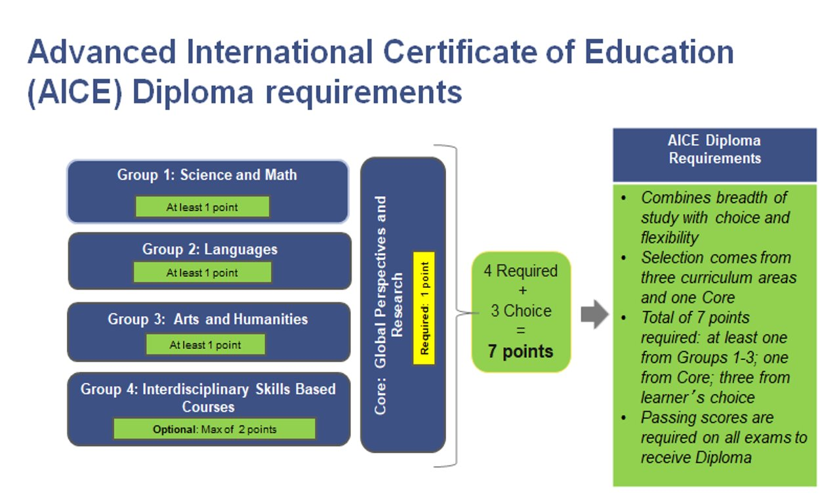
Core | Group 1 | Group 2 | Group 3 | Group 4
AS Global Perspectives | AS Level Math​  AS Level Biology​  AS Level Marine Science​  AS Level Informational Technology​  AS Level Environmental Management*​  AS Level Physical Education*​  AS Level Psychology*​ | AS English Language​  AS Spanish Language​ | AS Level History, US ​  AS Level History, Euro​  AS Level Drama​  AS Level Music​  AS Level Art & Design​  AS Level Media Studies​  AS Level English Literature​  AS Level Environmental Management*​  AS Level Physical Education*​  AS Level Psychology*​ | AS English General Paper​  AS Thinking Skills​

*Courses can count for either the Group 1 or Group 3 Requirement

Students have 25 months from their first exam to earn all 7 points for the AICE Diploma. The time begins when the student sits for their first exam.
Example: 1st Exam is the June 2021 series, starting in May of 2021. Students must earn all 7 points by June 2023.

